**وظيفة هندسة البرمجيات**

**F20الفصل:**

**اسماء الطلاب**

**الرقم:**

**الاسم:**

**الصف:**

**اسم الاستاذ:**

1. **التقنيات الانسب لجمع المتطلبات هي :**

* الاستبيانات : لان نحتاج لمقابلة اشخاص بالوزارة والشركات ووممكن نشر الاستبيان على موقع الوزارة لكي يجاوب عليه الشركات وطالبين الفرص
* استخدام التصاميم الاختبارية : لكي تشاهد الوزارة والشركات كيف سيكون شكل النظام بشكل اولي واخذ الاراء للوصول للمتطلبات بشكل واضح وملموس

1. **النماذج المقترحة:**

* النموذج التزايدي: لانه منظم ويسلم النظام على اقسام ويمكن للزبون مشاهدة اصدارات النظام والتفاعل معها

ويستخدم مبدئ فرق تسد للمهام

الكلفة اقل

ممكن ان يصل للزبون اهم الخدمات بالنظام والعمل بها

يقبل تعديل المتطلبات

واذا كانت المتطلبات ثابتة لا تتعدل ويمكن ان نحصل عليها بالبداية يمكن عندها استخدام نموذج الشلال لانه سهل الفهم يعطي نظام ذو جودة عالية وسريع بالانجاز

1. **الفاعلين وحالات الاستخدام :**

الفاعلين : مدير النظام والشركة وطالب الفرصة

يسمح النظام لمدير النظام بالقيام ب:

1-اضافة تصنيفات جديدة لفرص العمل

2- قبول تسجيل الشركات وطالبي الفرص

3-مشاهدة فرص العمل

4-رفض فرص العمل

5-حظر طالب فرصة عمل

6-اجراء استطلاعات

7-توليد التقارير

يسمح النظام للشركة بالقيام ب:

1-تسجيل حساب جديد

2-اضافة فرص عمل

3-مراجعة طلبات التوظيف

4-القبول المبدئي للطلب

5-رفض الطلب

6-ارسال رسالة للمقبولين

يسمح النظام للطالب الفرصة بالقيام ب:

1-تسجيل حساب جديد

2-اضافة شهادات لاحقا

3-تصنيف الوظائف

4-البحث عن وظيفة

5-استعراض الوظائف

6- تقديم طلب توظيف

1. **المتطلبات الغير وظيفية:**

- واجهات سهلة غير معقدة لتشمل الشريحة األكبر من طالبي فرص العمل ومقدميها بمختلف خبراتهم الحاسوبية

-الاداء العالي وتوزيع الاحمال عند ازديادها

-قابلية التوسع للتحسين واضافة مزايا جديدة

1. التوصيف التفصيلي لحالات الاستخدام:

|  |  |
| --- | --- |
| **Title: Add New Job Category** | |
| Actor: Admin. | |
| Brief description: An actor uses this case to add new job category. | |
| Precondition: Logged in | |
| Post condition: new category will be added to DB. | |
| Flow of events: Actor: | System: |
| 1- Click on add new item |  |
|  | 2-the system will show add form. |
| 3- the actor will fill the form |  |
| 4- Click Add |  |
|  | 5- the system will add the category to database. |
| Critical scenario: Actor: | System Response: |
| 1- No Internet Connection | Show message |
| 2- invalid input | Show message |

|  |  |
| --- | --- |
| **Title: Accept companies and users** | |
| Actor: Admin. | |
| Brief description: An actor uses this case to accept new users and companies. | |
| Precondition: Logged in | |
| Post condition: new user or company will be added to DB. | |
| Flow of events: Actor: | System: |
| 1- Click on accept |  |
|  | 2-the system will add selected user or company to db. |
|  | 3- the system will show message |
| Critical scenario: Actor: | System Response: |
| 1- No Internet Connection | Show message |

|  |  |
| --- | --- |
| **Title: Reject job occasions** | |
| Actor: Admin. | |
| Brief description: An actor uses this case to Reject job occasions. | |
| Precondition: Logged in | |
| Post condition: update flag value. | |
| Flow of events: Actor: | System: |
| 1- Select job occasions |  |
| 2- Click Reject |  |
|  | 3- the system will update flag in Database |
| Critical scenario: Actor: | System Response: |
| 1- No Internet Connection | Show message |

|  |  |
| --- | --- |
| **Title: View job occasions** | |
| Actor: Admin, user. | |
| Brief description: An actor uses this case to View job occasions. | |
| Precondition: Logged in | |
| Post condition: - | |
| Flow of events: Actor: | System: |
| 1- Click on View all occasions |  |
|  | 2-the system will show all occasions. |
| Critical scenario: Actor: | System Response: |
| 1- No Internet Connection | Show message |

|  |  |
| --- | --- |
| **Title: block users** | |
| Actor: Admin. | |
| Brief description: An actor uses this case to black users. | |
| Precondition: Logged in | |
| Post condition: update flag value. | |
| Flow of events: Actor: | System: |
| 1- Select user |  |
| 2- Click block |  |
|  | 3- the system will update flag in Database |
| Critical scenario: Actor: | System Response: |
| 1- No Internet Connection | Show message |

|  |  |
| --- | --- |
| **Title: Create polls** | |
| Actor: Admin. | |
| Brief description: An actor uses this case to Create polls. | |
| Precondition: Logged in | |
| Post condition: - | |
| Flow of events: Actor: | System: |
| 1- Click Create polls |  |
|  | 2-the system will show form |
| 3- Actor will fill the form |  |
| 4-Click create |  |
| Critical scenario: Actor: | System Response: |
| 1- No Internet Connection | Show message |

|  |  |
| --- | --- |
| **Title: Generate Reports** | |
| Actor: Admin. | |
| Brief description: An actor uses this case to Generate reports. | |
| Precondition: Logged in | |
| Post condition: new report will be added to DB | |
| Flow of events: Actor: | System: |
| 1- Click Generate |  |
|  | 2-the system will show form |
| 3- Actor will fill the form |  |
| 4-Click Generate |  |
|  | 5-the system will add the report to database |
| Critical scenario: Actor: | System Response: |
| 1- No Internet Connection | Show message |

|  |  |
| --- | --- |
| Title: **Register** | |
| Actor: Company, User | |
| Brief description: This use case is for create a new account | |
| Precondition: - | |
| Post condition: new account will be added | |
| Flow of events: Actor: | System: |
| 1- The actor will request register | 2- The system shows the register form |
| 3- the actor will fill the form and submit | 4- the system will create an account |
| Critical scenario: Actor: | System Response: |
| 1- No Internet Connection | Show message |
| 2- invalid input | Show message |

|  |  |
| --- | --- |
| Title: **Add new job occasions** | |
| Actor: Company, User | |
| Brief description: This use case is to add new job occasion. | |
| Precondition: Logged in as Company | |
| Post condition: new job occasion will be added | |
| Flow of events: Actor: | System: |
| 1- The actor will request add new occasion | 2- The system shows the register form |
| 3- the actor will fill the form and submit | 4- the system will add new occasion to database |
| Critical scenario: Actor: | System Response: |
| 1- No Internet Connection | Show message |
| 2- invalid input | Show message |

|  |  |
| --- | --- |
| Title: View job occasions | |
| Actor: Company | |
| Brief description: This use case is for showing all job occasions. | |
| Precondition: logged in | |
| Post condition: - | |
| Flow of events: Actor: | System: |
| 1-the user will request view occasions | 2- the system will show list of occasions |
| Critical scenario: Actor: | System Response: |
| 1- No Internet Connection | Show message |

|  |  |
| --- | --- |
| Title: Initial acceptance | |
| Actor: Company | |
| Brief description: This use case is for Initial acceptance of job request. | |
| Precondition: logged in | |
| Post condition: update flag in DB | |
| Flow of events: Actor: | System: |
| 1-the user will select request |  |
| 2- Click Accept |  |
|  | The system will update flag of request. |
| Critical scenario: Actor: | System Response: |
| 1- No Internet Connection | Show message |

|  |  |
| --- | --- |
| Title: Reject Requests | |
| Actor: Company | |
| Brief description: This use case is for reject job request. | |
| Precondition: logged in | |
| Post condition: update flag in DB | |
| Flow of events: Actor: | System: |
| 1-the user will select request |  |
| 2- Click Reject |  |
|  | The system will update flag of request. |
| Critical scenario: Actor: | System Response: |
| 1- No Internet Connection | Show message |

|  |  |
| --- | --- |
| Title: Send Email | |
| Actor: Company | |
| Brief description: This use case is for sending email for accepted users. | |
| Precondition: logged in | |
| Post condition: - | |
| Flow of events: Actor: | System: |
| 1-the user will select accepted users |  |
| 2- Click send email |  |
|  | 3- The system will show send email form. |
| 4- the user will fill the form and click send |  |
|  | 5-the system will send the email |
| Critical scenario: Actor: | System Response: |
| 1- No Internet Connection | Show message |

|  |  |
| --- | --- |
| Title: **Filter jobs** | |
| Actor: User | |
| Brief description: This use case is for filtering the jobs. | |
| Precondition: logged in as user | |
| Post condition: | |
| Flow of events: Actor: | System: |
| 1- The actor will request filter | 2- The system shows the filter list |
| 3- the actor will choose filter by. | 4- the system will show filtered jobs |
| Critical scenario: Actor: | System Response: |
| 1- No Internet Connection | Show message |

|  |  |
| --- | --- |
| Title: **Add new diploma** | |
| Actor: User | |
| Brief description: This use case is to add new diploma | |
| Precondition: logged in as user | |
| Post condition: new diploma will be added | |
| Flow of events: Actor: | System: |
| 1- The actor will request add new diploma | 2- The system shows the add form |
| 3- the actor will fill the form and submit | 4- the system will add new diploma to database |
| Critical scenario: Actor: | System Response: |
| 1- No Internet Connection | Show message |
| 2- invalid input | Show message |

|  |  |
| --- | --- |
| Title: **Apply job request** | |
| Actor: User | |
| Brief description: This use case is for apply a new job request. | |
| Precondition: log in as user | |
| Post condition: new job request will be added | |
| Flow of events: Actor: | System: |
| 1- The actor will request register job | 2- The system shows the register form |
| 3- the actor will fill the form and submit | 4- the system will add new job request. |
| Critical scenario: Actor: | System Response: |
| 1- No Internet Connection | Show message |
| 2- invalid input | Show message |

|  |  |
| --- | --- |
| Title: **Login** | |
| Actor: Admin, Company, User | |
| Brief description: This use case is for Login to account | |
| Precondition: register for one time | |
| Post condition: - | |
| Flow of events: Actor: | System: |
| 1-the user will request login | 2- the system will show login form |
| 3- the user will enter credentials | 4- the system will open the profile |
| Critical scenario: Actor: | System Response: |
| 1- No Internet Connection | Show message |
| 2- invalid input | Show message |
| 3- no input | Show message |
| 4- email or password is incorrect | Show message |

مخطط حالات الاستخدام:

لطالب فرصة العمل

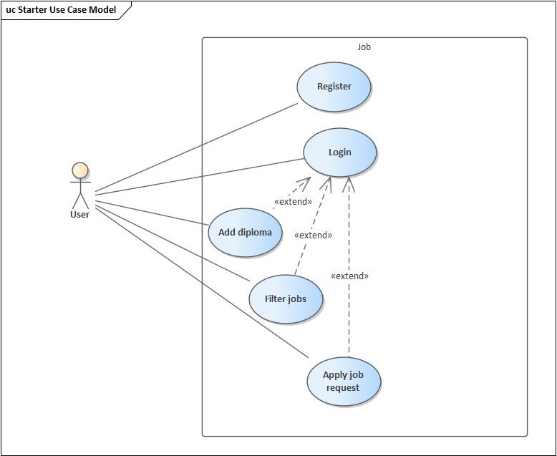

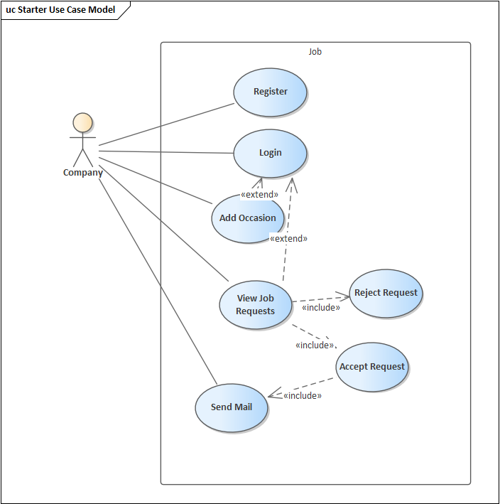

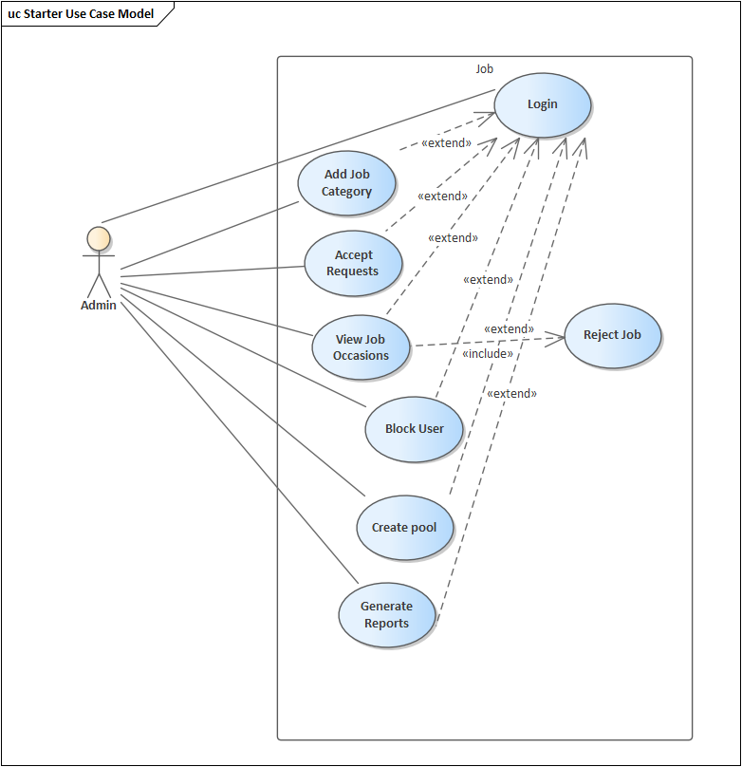

مخطط النشاط:

تسجيل الدخول

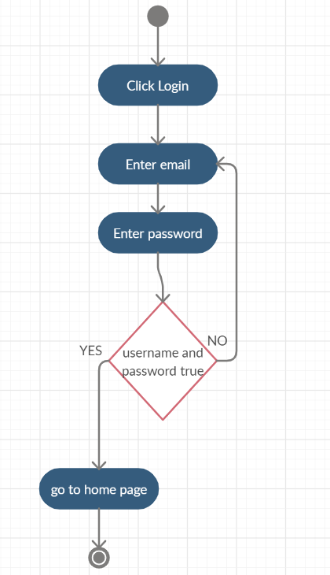

تسجيل حساب جديد:

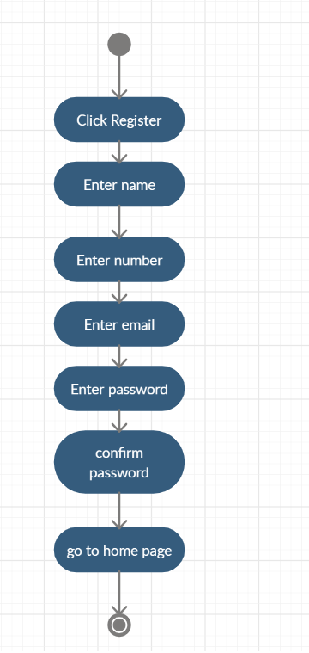

استعراض الاعمال:

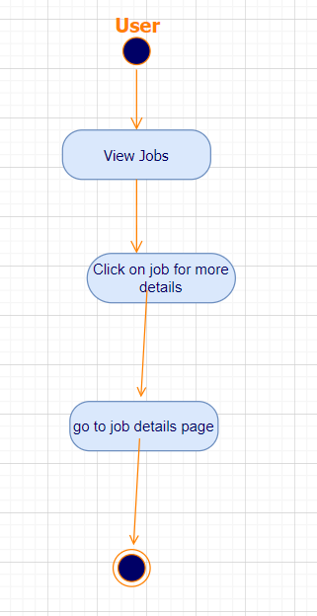

المخطط التسلسلي:

تسجيل الدخول:

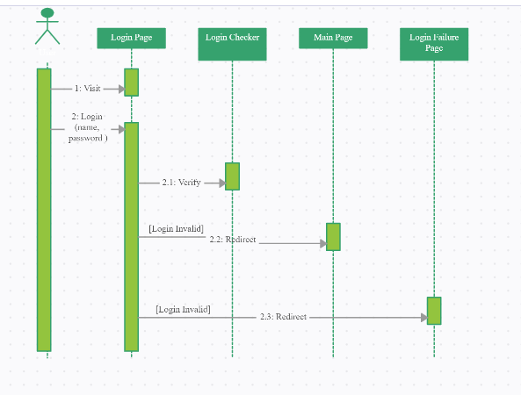

تسجيل حساب جديد:

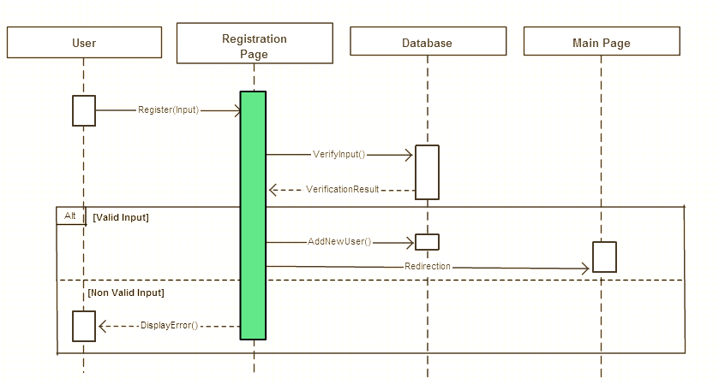

استعراض كل الاعمال:

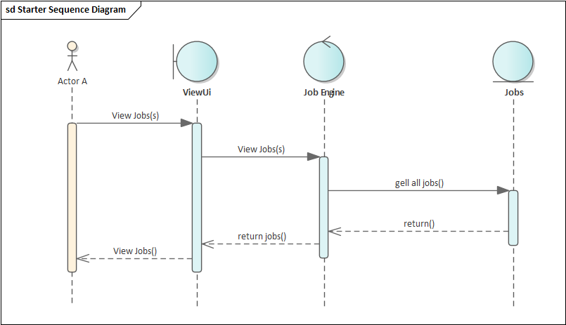

مخطط الصفوف:

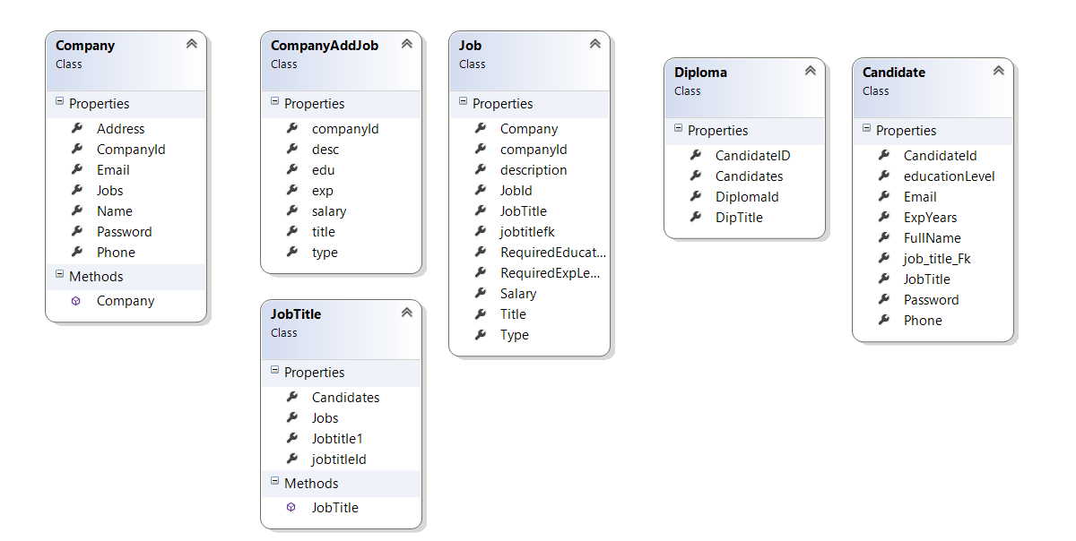

مخطط الحالة:

